Introduction
Partial discharge (PD) happens when a small area of insulation in a high voltage environment cannot cope with the electrical stress and breaks down. It doesn’t span the whole distance between two insulated electrodes – that’s why it’s called ‘partial’. Partial discharge might be small in size, but it does cause insulation to deteriorate over time, which will ultimately lead to failure. If left unchecked, insulation failure can result not only in loss of supply to processes or customers but can also endanger staff. The image shows how PD emits energy. Non-intrusive instruments use the electromagnetic and ultrasonic emissions to detect problems. However, when entering a substation, you should always use your own senses. Look for signs of stress, smell for ozone, listen for audible crackling from within switchgear. Any of these indicators can be a sign of severe PD and an unsafe environment.
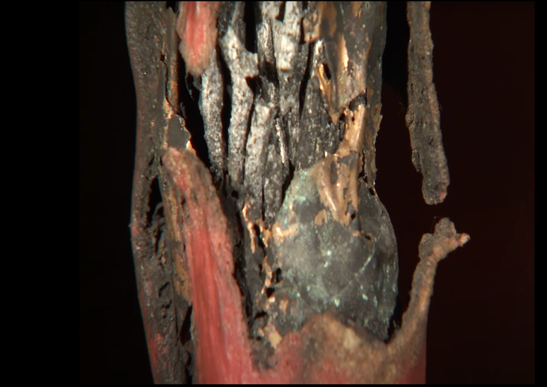
https://www.youtube.com/watch?v=22GGAorNkwA&ab_channel=OMICRONenergy

Types of partial discharge

Corona Discharge: This common form of partial discharge occurs when discharge is directly into the air emanating from the sharp surface of the conductor. (This is what causes the sound and radio frequency emissions.)
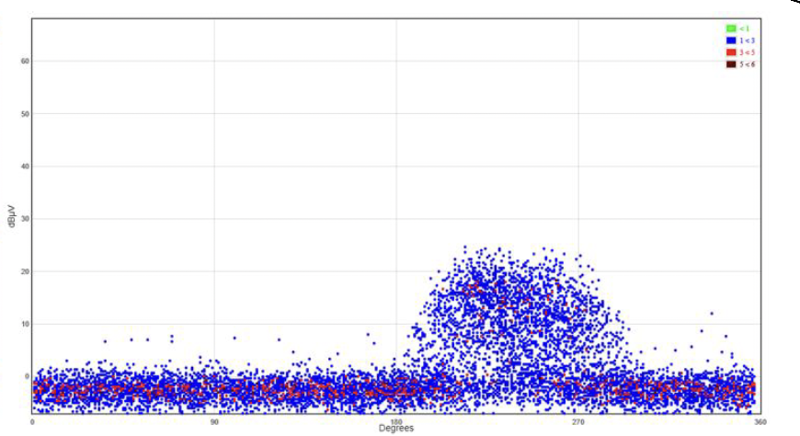

- Discharges occurring in the strongly inhomogeneous field around a sharp point or edge of electrode

Surface Discharge: When discharge travels along the surface of insulation. It can be one of the most destructive types of partial discharge. Contamination and weather of the insulator surface are the two most common causes of surface discharge. In medium- and high-voltage equipment, this type of discharge occurs when insulation breaks down, usually due to high humidity or poor maintenance. Moisture intrusion is also a common cause of surface discharge.
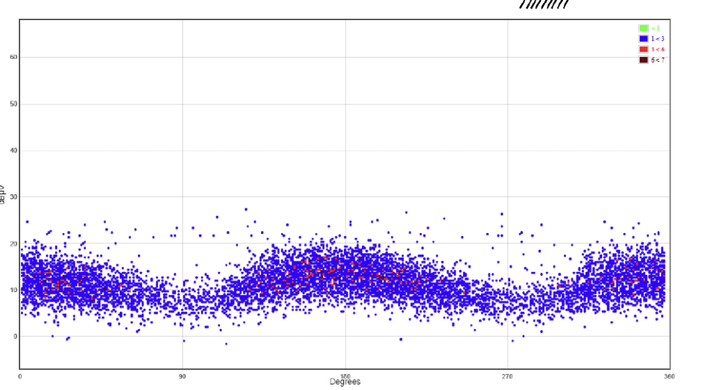

- Discharges occurring at the surface of a dielectric

- May occur if there is a electrical stress parallel to a dielectric surface

Void (internal) Discharge: This is most often caused by a defect in the solid insulation of cables, bushings, and such. Void discharge is highly destructive to insulation and will typically continue to expand until they cause complete failur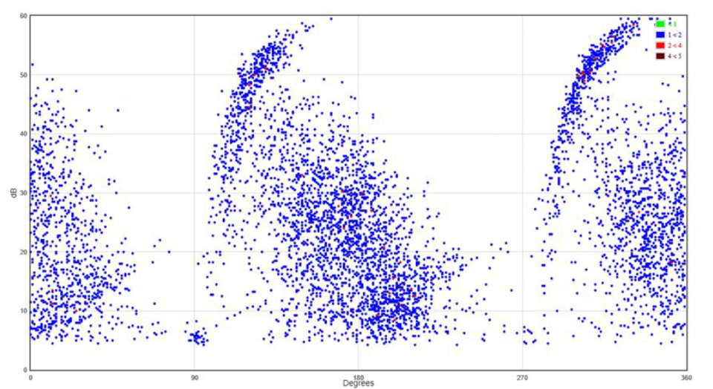

- Discharges occurring in inclusions or cavities in a dielectric
- In general, the larger the cavity, the larger the discharge magnitude

Experiment:
How is Partial Discharge testing done on cables?

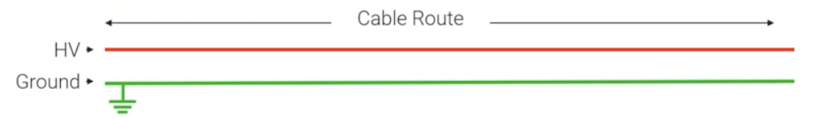
When partial discharge happening in cables then high frequency pulses are generated that travel along the conductor and in the opposite polarity of along the sheath of the cable.

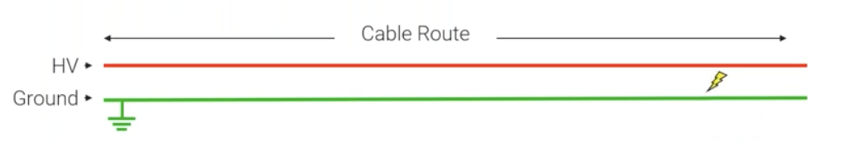
When PD is happening at a location

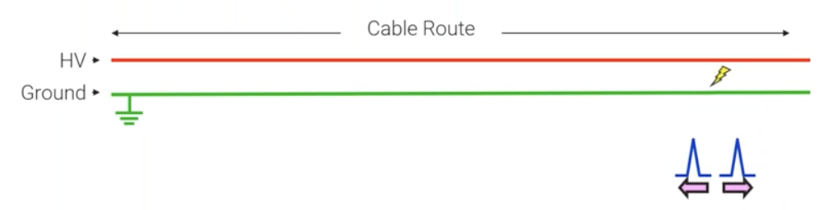
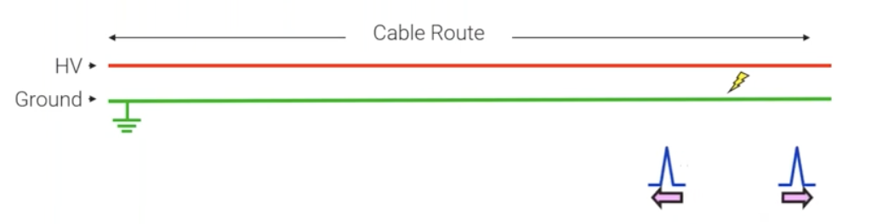
A signal will be generated that travel along the ground and travel up the conductor in the opposite polarity.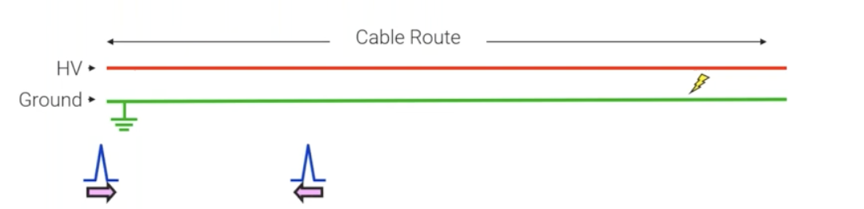
The signal will travel in both direction until it see the end of the cable and the change of impendence the signal will then bounce back.

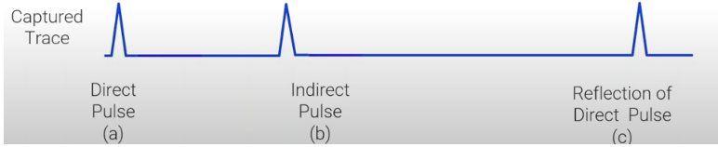

The first pulse (a) will be coming directly from the discharge side at the sensor, followed by the indirect pulse(b) is going to start at the discharge side and travel down to the far end of the cable come back down to the sensing point. Reflection pulse is the reflection of the first pulse (a) after going all the way to the end of the cable and back to sensing point.

From the signal we can obtain:
- Measure the amplitude.
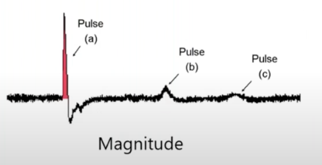
- Locate the fault on the cable.
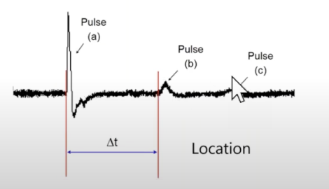

From (a) to (c) : It will shows the length of the cable
From (a) to (b) : It shows the Partial Discharge location

$$Distance=Speed × Time$$

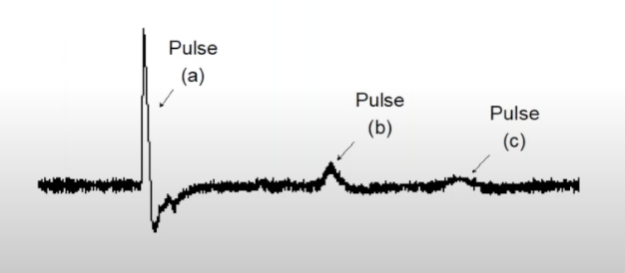

Factors that affected the signal attenuation
- Type of cable (e.g attenuation is lesser on XLPE compared to paper cable)
- Length (The longer the cable, the more high frequency component will be lost)
- Loading condition (when noises can affect the reading of signal)
- Propagation characteristics

Question 1: What is Partial Discharge?
A: A flashover from high voltage to ground
B: A partial breakdown of insulation
C: A fault detection technique

Question 2: Which of the following are emitted by Partial Discharge?
A: Radio waves & Gamma Rays
B: Sound & Gamma Rays
C: Radio Waves & Sound

Question 3: The 3 main classifications of Partial Discharge are?
A: Internal, Surface, Pulsing
B: Internal, Surface, Corona
C: Internal, Pulsing, Corona

Question 4: What does a Phase Resolved Partial Discharge Pattern (PRPD) display?
A: Amplitude of partial discharge vs phase angle relative to system frequency
B: Voltage vs current of partial discharge signal
C: Amplitude vs discharge rate

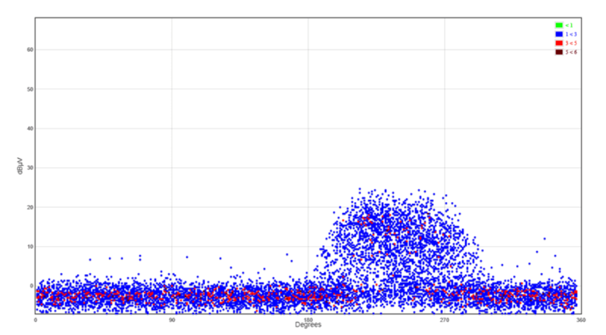
Question 5: Diagnose the following ultrasonic PRPD plot.
A: Noise
B: Internal Void
C: Surface Partial Discharge
D: Corona

Question 6: Through which of the following do airborne ultrasonic waves pass?
A: Steel
B: Air Gaps
C: Insulators:
D: Gaskets

Question 7: What is the typical duration of a PD event?
A: More than 100us
B: Between 100us and 1ms
C: Less than 1us
D: Between 5us and 10us

Question 8: Which type of Partial Discharge is affected by environmental condition?
A: Surface and Corona Discharge
B: Internal and Surface Discharge
C: Internal and Corona Discharge

Question 9: When measuring broadband PD signals, HF signals will attenuate quicker than UHF. True or false?
A: True
B: False

Question 10: Diagnose the following Transient Earth Voltage (TEV) PRPD plot.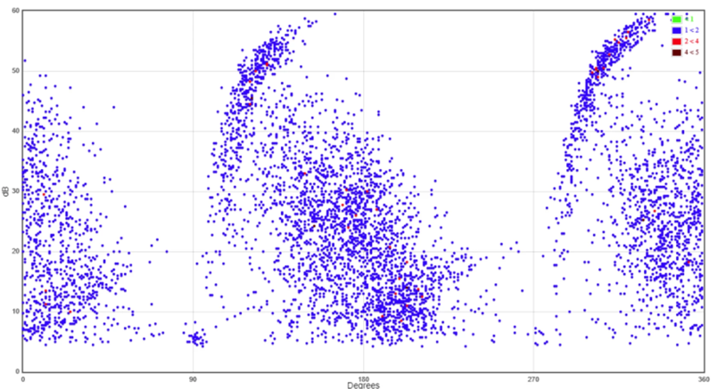
A: Noise
B: Surface Partial Discharge
C: Internal Void
D: Corona

Reference:
https://eatechnology.com/australia/resources/blogs/high-voltage/what-is-a-partial-discharge-phase-plot-telling-you/
https://www.fluke.com/en-sg/learn/blog/leak-detection/partial-discharge
https://eatechnology.com/americas/resources/faq/partial-discharge-testing-of-cables/
https://www.youtube.com/watch?v=22GGAorNkwA&ab_channel=OMICRONenergy

